# Annexure3b- Complete filing

# INVENTION DISCLOSURE FORM

Details of Invention for better understanding:

**1. TITLE:** AUTOMATIC FUEL BLENDING SYSTEM

**2. INTERNAL INVENTOR(S)/ STUDENT(S):** All fields in this column are mandatory to be filled

|  |  |
| --- | --- |
| A. Full name | MIDLAJ K.P |
| ­­­­­Mobile Number | 6282362105 |
| Email (personal) | midlajkp313786@gmail.com |
| UID/Registration number | 12212894 |
| Address of Internal Inventors | Lovely Professional University, Punjab-144411, India |
| Signature (Mandatory) |  |

|  |  |
| --- | --- |
| B. Full name | ABEL JOY |
| ­­­­­Mobile Number | 7558956165 |
| Email (personal) | abel.joy.2412@gmail.com |
| UID/Registration number | 12205763 |
| Address of Internal Inventors | Lovely Professional University, Punjab-144411, India |
| Signature (Mandatory) |  |

|  |  |
| --- | --- |
| C. Full name | YADHUKRISHNAN |
| ­­­­­Mobile Number | 9946015876 |
| Email (personal) | yadhuyk3@gmail.com |
| UID/Registration number | 12211253 |
| Address of Internal Inventors | Lovely Professional University, Punjab-144411, India |
| Signature (Mandatory) |  |

|  |  |
| --- | --- |
| D. Full name | BHAVYALAKSHMI O.S |
| ­­­­­Mobile Number | 7034671816 |
| Email (personal) | bhavyalakshmios11@gmail.com |
| UID/Registration number | 12205644 |
| Address of Internal Inventors | Lovely Professional University, Punjab-144411, India |
| Signature (Mandatory) |  |

**3.DESCRIPTION OF THE INVENTION:**

The invention relates to an Automatic fuel blending system for automotive vehicles, specifically designed to enhance fuel efficiency and reduce the emission of harmful pollutants. The system continuously monitors and analyses exhaust gases, including hydrocarbons, carbon monoxide (CO), carbon dioxide (CO₂), and particulate matter. Based on these real-time emission data, the system dynamically adjusts the blend of fuels used in combustion, thereby optimizing fuel economy and achieving a significant reduction in environmental pollutants.

The system operates by injecting a calculated amount of additives based on the current emission levels detected in the vehicle exhaust. The additive blend is formulated to enhance fuel combustion efficiency, which results in a reduction of CO, HC, and particulate emissions. This improved combustion also promotes better mileage and reduced engine strain, ultimately leading to fewer maintenance requirements.

This technology is beneficial for both environmental and economic purposes, providing an effective solution to meet stringent emissions standards while enhancing vehicle performance.

**A. PROBLEM ADDRESSED BY THE INVENTION:**

India is the fourth-largest emitter of greenhouse gases (GHGs), contributing approximately 7.08% of global emissions and ranking third among countries with the worst air quality. The present invention addresses several critical issues associated with vehicular emissions, particularly the high levels of greenhouse gases and pollutants released into the atmosphere. Carbon dioxide (CO₂) is a significant contributor to global warming and climate change with the transportation sector contributing approximately 24% of global CO₂ emissions. In India, CO₂ emissions from transportation play a major role in the nation’s greenhouse gas profile. Additionally, carbon monoxide (CO) presents serious health risks by impairing the body's ability to absorb oxygen, particularly in urban areas with high traffic density. Particulate matter (PM) is associated with respiratory and cardiovascular diseases and the transport sector in India is responsible for approximately one-third of PM pollution and 20-35% of urban PM₂.₅ pollution. Hydrocarbons (HC) contribute to the formation of smog and ground-level ozone, which are major air pollutants with harmful effects on both human health and the environment.

Currently, the manual application of additives relies on the judgment of mechanics, lacking precise emission monitoring. This inconsistent approach leads to ineffective combustion, suboptimal fuel efficiency, and engine degradation. The absence of automation further exacerbates the issues, resulting in higher fuel consumption and increased environmental pollution. To address these challenges, there is a need for a system that monitors emissions in real time, determines the exact amount of fuel additives required ensuring zero wastage of additive, dynamically adjusts fuel composition to optimize combustion, reduces emissions, and enhances vehicle performance and fuel efficiency while minimizing engine wear.

**B. OBJECTIVE OF THE INVENTION**

1. **Reduce Emission Levels**  
   To minimize the release of harmful pollutants such as CO, hydrocarbons, CO₂, and particulate matter by optimizing the fuel blend with suitable additives, thus contributing to cleaner and more eco-friendly vehicle operations.
2. **Enhance Fuel Efficiency and Engine Performance**:  
   To improve overall fuel efficiency, reduce maintenance costs, and increase engine performance by implementing a smart blending mechanism that ensures the ideal mixture of fuel and additives based on real-time emission and performance data.

**C. STATE OF THE ART/ RESEARCH GAP/NOVELTY:** Describe your invention fulfil the research gap?

|  |  |  |  |  |
| --- | --- | --- | --- | --- |
| Sr. No. | Patent I’d | Abstract | Research Gap | Novelty |
| 1. | EP0733796B1  Fuel blending system, method and apparatus | The system includes an adjustable blending valve with two entry ports and one exit port. Each entry port is connected to the discharge line of the respective fuel pumps. A blending valve includes a spool device which as it moves, increases the portion of one reference fuel as it decreases the portion of the other fuel to vary the octane rating of the blended-flow from the exit port. A float-controlled needle valve is positioned in the mixed fuel flow path which limits the mixed fuel flow to that which the engine is burning. An integral processing device which senses a flow from included flow meters to compute a percent of each test fuel A and B in the blend and the octane rating of the blended stream. | The patent addresses the blending of two fuels to adjust octane levels but does not consider emissions control, additive use, or real-time monitoring. It lacks a dynamic approach to fuel blending based on environmental emissions data and does not account for multi-fuel adaptability or additive dosagecontrol for optimized emissions reduction. There is also no focus on the real-time intervention needed to optimize performance based on environmental data. | Our system **dynamically adjusts the fuel blend based on emissions data** to optimize fuel efficiency and reduce pollutants like CO, CO2, and particulate matter, while the patent focuses solely on adjusting octane ratings. It also integrates **additives** fo**r** emissions control and fuel efficiency, which the patent does not address. Furthermore, our system employs **real-time monitoring** for continuous emissions data and **precise additive dosage control**, eliminating wastage and ensuring optimal additive use based on real-time emissions levels. |
| 2. | US5163586A  Automotive fuel additive dispensing and blending system | An automotive fuel additive dispensing and blending system is described wherein both proprietary and mandated fuel additives heretofore normally added at the refinery or a bulk storage plant may be added at a service station and blended into the fuel as fuel is dispensed thereby allowing most effective and reliable addition of additives that may be volatile and that may degrade in storage after mixed with fuel as well as providing a cost effective method for supplying differing gasoline blends to the customer. | The research gap in this system lies in its lack of emissions control and its focus solely on additives without addressing the dynamic blending needed for optimizing fuel efficiency and emissions. | Our system incorporates additives dynamically, adjusting the dosage based on real-time emissions data for optimized fuel efficiency and emissions reduction. The system ensures that additives are used precisely, reducing waste and eliminating the risks associated with over-dosing. In contrast, our system addresses not only additive blending but also emissions control, IoT-based real-time monitoring, and fuel efficiency, making it a more comprehensive solution for modern automotive needs. |
| 3. | US-20110233233-AI  Method of blending fuels and related system | A method and related system blend fuels and dispense a blended fuel to a vehicle at a fueling station. In one aspect, the method comprises selecting the desired proportion of at least one of the fuels available at the service station, blending that fuel with another one available, and delivering the blended fuel to the vehicle. Preferably, the first fuel is a non-renewable, petroleum based one, while the second fuel is a non-petroleum based, renewable one (such as ethanol or biodiesel). | The patent lies in its focus on fuel blending for providing specific fuel proportions at service stations but does not address the dynamic optimization of fuel blends based on real-time emissions data or engine performance. | Unlike US-20110233233-A1, which blends specific fuel types, our system blends fuels dynamically based on emissions, reducing waste and enhancing fuel efficiency across various fuel types. Moreover, it adds emissions control and efficiency optimization, addressing a wider range of environmental and performance factors. |

**D. DETAILED DESCRIPTION:**   
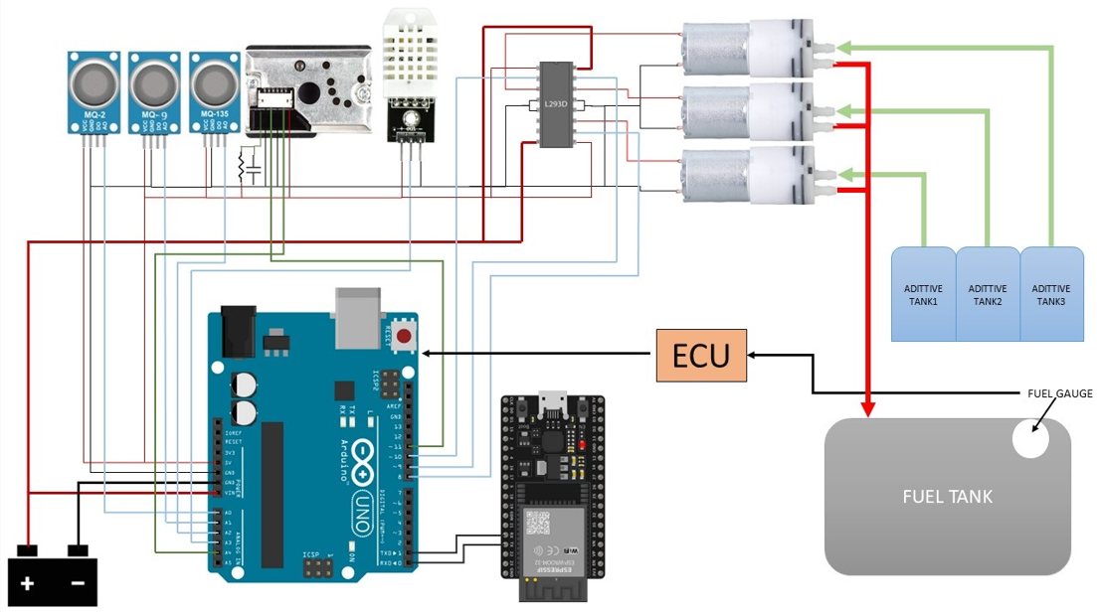

The Automatic Fuel Blending System circuit is designed to reduce vehicle emissions and improve engine efficiency by integrating real-time pollutant detection, additive dispensing, and IoT-based monitoring. The system incorporates multiple sensors, including MQ2, MQ9, and MQ135 gas sensors for detecting gases like CO, CO2, CH4, and other air pollutants, along with a particulate matter sensor (GP2Y1010AU0F) for monitoring PM2.5 and PM10 levels. Environmental factors such as temperature and humidity, which influence fuel efficiency, are measured using the DHT22 sensor. These sensors are interfaced with the Arduino UNO, which acts as the central controller, processing data and determining the required additive quantities based on pollutant levels and fuel volume. The system communicates emission data and environmental parameters to a remote IoT platform via the ESP32 module, enabling real-time monitoring.

The fuel gauge monitors the fuel level and shares data with the Electronic Control Unit (ECU), which in turn relays this information to the Arduino for precise additive calculations. Additives stored in three separate tanks are dispensed using DC motors controlled by an L293D motor driver. The Arduino activates these motors based on pollutant levels, blending the additives into the fuel tank to reduce harmful emissions and enhance engine performance. The system is powered by a combination of external batteries and voltage-regulated power supplies, ensuring stable operation for all components.

This workflow ensures efficient pollutant detection, fuel blending, and IoT-based emission monitoring. It optimizes the use of fuel additives to achieve reduced emissions, improved engine performance, and sustainable vehicle operation. The integration of sensors, real-time data processing, and IoT connectivity makes this system a cost-effective and environmentally friendly solution to address vehicle emissions and improve fuel efficiency.

**E. RESULTS AND ADVANTAGES:**

RESULTS  
The invention significantly improves vehicle performance by dynamically adjusting fuel blends in real-time, leading to a reduction in harmful emissions, such as CO, CO2, and particulate matter. The system incorporates fuel borne, cetane based and injector cleaning additives, resulting in up to significant decrease in emissions as demonstrated in preliminary testing. Additionally, fuel efficiency improves by **7-10%**, a value provided by the additive manufacturer, based on the amount of emission reduced per millilitre of additive. This is further facilitated by the additives, which enhance engine performance. The system integrates seamlessly with IoT devices, allowing for continuous monitoring and real-time transmission of emission data, ensuring that the fuel blend is adjusted promptly when needed to maintain optimal performance. Furthermore, the system contributes to cost savings by reducing maintenance needs due to fewer engine deposits and less wear-and-tear, and it decreases overall fuel consumption, offering long-term financial benefits to users.

MATHEMATICAL CALCULATIONS

The equation for calculating the required dosage of additives can be expressed as follows:

**Additive Dosage Calculation Formula**

Required Dosage (mL) = ΔE

K

* **ΔE (Change in Emission)** is the difference between the current emission level and the expected reduction in emissions (i.e., the target emission level after additive application).
* **K** is a constant provided by the manufacturer of the additive, representing the amount of reduction in emissions (in ppm) achieved per milliliter of the additive.  
    
  We are incorporating additives in the category of fuel-borne catalysts to reduce carbon monoxide and particulate matter emissions (e.g., HiTEC® 5200). Additionally, cetane improvers (for e.g. Amsoil cetane boost) are used to enhance combustion efficiency and increase the cetane number, while injector cleaners (for e.g. Amsoil injector cleaner) are employed to minimize hydrocarbon emissions by cleaning injectors and improving overall engine maintenance.
* K for HiTEC® 5000(CO)-72 ppm/ml  
  K for HiTEC® 5000(PM)-1.9 ppm/ml  
  K for Amsoil Cetane Booster(CO₂)-4400 ppm/ml  
  K for Amsoil Injector Cleaner (HC)-5 ppm/ml

Calculation for HiTEC® 5000(CO)  
   
 Required Dosage = Current emission – Expected reduction  
 K  
  
 = 1800-500  
 72  
 = 18.05ml  
  
Similarly, we can find the required dosage required to reduce different emissions.

|  |  |  |  |
| --- | --- | --- | --- |
| Pollutant | Current emission (in ppm) | Expected reduction (in ppm) | Required amount of additive(ml) |
| CO | 1800 | 500 | 18.05 |
| HC | 100 | 20 | 16 |
| CO2 | 80K | 130K | 11.36 |
| PM | 35 | 10 | 13.15 |

ADVANTAGES

The system offers significant advantages over existing technologies. The fuel blending system also provides a dual benefit by reducing emissions while improving fuel efficiency, offering a more comprehensive solution to environmental concerns compared to current systems that often target only one aspect, such as emission reduction or fuel economy. The system's integration with IoT allows users to monitor emissions and fuel consumption in real-time, a feature that traditional emission control systems lack, thus enabling faster identification and resolution of inefficiencies. Additionally, the system is designed with user-friendliness in mind, offering a smartphone-based interface that simplifies operation without requiring specialized knowledge or expensive diagnostic equipment, making it accessible for a wider user base. The system’s ability to optimize fuel usage and reduce engine wear results in lower maintenance and repaircosts, making it a cost-effective solution compared to traditional emission control systems that require costly maintenance or replacement of parts.

SUPIRIORITY OVER EXISTING PRIOR ART

The invention provides several key improvements over existing technologies. One significant advancement is the dynamic fuel blending capability, which adapts the fuel mixture in real-time based on emissions data, ensuring that the engine operates at optimal efficiency under varying conditions. Existing systems typically rely on fixed or static blending ratios, which do not adjust to changing engine performance or environmental factors, making the disclosed system more responsive and efficient.

Furthermore, the system’s ability to precisely dose additives addresses a major limitation in current systems. By using real-time emission data to determine the correct amount of additives required, it prevents both the wastage of additives and the problems caused by overdosage. Overuse of additives can lead to engine issues such as clogging or inefficient combustion, while underuse may result in inadequate emission control. The system optimizes additive use, ensuring that the correct amount is added based on the actual emissions level, thus preventing these issues and improving overall efficiency.

The integration of IoT-enabled continuous monitoring further enhances the system’s performance. Unlike traditional systems that only offer periodic checks or post-hoc adjustments, this system provides real-time data on emissions and fuel consumption, allowing for immediate corrective actions. This proactive monitoring system ensures that any inefficiencies or issues are addressed quickly, unlike conventional systems that tend to react to problems only after they arise.

**F. EXPANSION:**

**Exponential regression** algorithm is commonly used to interpret the readings from gas sensors like the MQ series. These sensors typically produce a non-linear output, so an exponential or logarithmic regression helps in accurately mapping the sensor’s resistance or output voltage to gas concentration (e.g., ppm).

Y=A.e^B-x

Where,

* Y is the gas concentration (in ppm)
* X is the sensor’s resistance ratio (or sometimes voltage)
* A and B are constants determined from calibration data specific to the sensor and gas type.

**G. WORKING PROTOTYPE/ FORMULATION/ DESIGN/COMPOSITION:   
**

The Automatic Fuel Blending System circuit is designed to reduce vehicle emissions and improve engine efficiency by integrating real-time pollutant detection, additive dispensing, and IoT-based monitoring. The system incorporates multiple sensors, including MQ2, MQ9, and MQ135 gas sensors for detecting gases like CO, CO2, CH4, and other air pollutants, along with a particulate matter sensor (GP2Y1010AU0F) for monitoring PM2.5 and PM10 levels. Environmental factors such as temperature and humidity, which influence fuel efficiency, are measured using the DHT22 sensor. These sensors are interfaced with the Arduino UNO, which acts as the central controller, processing data and determining the required additive quantities based on pollutant levels and fuel volume. The system communicates emission data and environmental parameters to a remote IoT platform via the ESP32 module, enabling real-time monitoring.

The fuel gauge monitors the fuel level and shares data with the Electronic Control Unit (ECU), which in turn relays this information to the Arduino for precise additive calculations. Additives stored in three separate tanks are dispensed using DC motors controlled by an L293D motor driver. The Arduino activates these motors based on pollutant levels, blending the additives into the fuel tank to reduce harmful emissions and enhance engine performance. The system is powered by a combination of external batteries and voltage-regulated power supplies, ensuring stable operation for all components.

This workflow ensures efficient pollutant detection, fuel blending, and IoT-based emission monitoring. It optimizes the use of fuel additives to achieve reduced emissions, improved engine performance, and sustainable vehicle operation. The integration of sensors, real-time data processing, and IoT connectivity makes this system a cost-effective and environmentally friendly solution to address vehicle emissions and improve fuel efficiency.

**H. EXISTING DATA:**   
The table summarizes the emission reduction performance of the System. It compares the emission levels of three key pollutants Carbon Monoxide (CO), Particulate Matter (PM), and Hydrocarbons (HC) before and after implementing the system. The reductions are achieved through the precise injection of additives into the fuel, optimizing combustion, and reducing harmful emissions.  
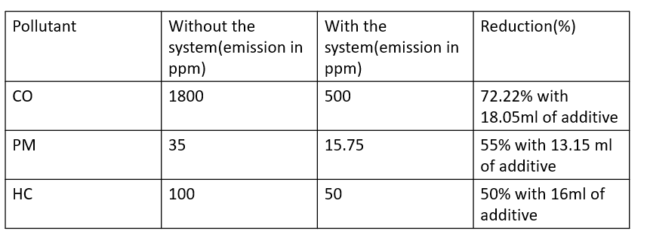

**4.USE AND DISCLOSURE (IMPORTANT):** Please answer the following questions:

|  |  |  |
| --- | --- | --- |
| 1. Have you described or shown your invention/ design to anyone or in any conference? | YES ( ) | NO ( ) |
| 1. Have you made any attempts to commercialize your invention (for example, have you approached any companies about purchasing or manufacturing your invention)? | YES ( ) | NO ( ) |
| 1. Has your invention been described in any printed publication, or any other form of media, such as the Internet? | YES ( ) | NO ( ) |
| 1. Do you have any collaboration with any other institute or organization on the same? Provide name and other details. | YES ( ) | NO ( ) |
| 1. Name of Regulatory body or any other approvals if required. | YES ( ) | NO ( ) |

10**. FILING OPTIONS:** Please indicate the level of your work which can be considered for provisional/ complete/ PCT filings (Mandatory to mention).

11. **KEYWORDS:** Automatic fuel blending system, fuel efficiency, Emission Reduction, fuel additives, Low carbon footprint,

**NO OBJECTION CERTIFICATE**

This is to certify that I (Name of the external person) have no financial assistance in filing any patent form from Lovely Professional University.

We have no objection if Lovely Professional University files any patent with the name of our employee (name of the external person) as co-inventor with (Names of LPU faculty/Staff and all co-inventors) having title as per the patent idea request file (LPU Idea Request I’D….).

Further, our institution will not raise any objections later concerning the filing and commercialization of the said patent.

(Authorised Signatory)

**`**